 | FACULTY Of INFORMATION, COMMUNICATION AND TECHNOLOGY  DEPARTMENT OF SOFTWARE ENGINEERING
CLASS TEST 1 MEMORANDUM

Subject Code : DSO23BT/SFW20BT
Subject Name : Development Software 2B/Software Skills 2B
Examiners) : S.K Mogapi
Moderator : V Ranko

Marks : 35 Time : 90 Minutes

Total Pages Including this one) : 4 Annexures) : 1

Rules
- Read and understand the question before you answer. Answer all the questions.
- Your answers should produce the same output as the ones the examiners) has given as examples.
- Complete the information on this cover page before you start answering questions.
- The question paper is based on the Summit Sporting Goods database. Install the database on your computer.
- Complete required details on the top of the notepad and save it as YourStudentNUmberCT1_2015.
- It’s your responsibility to make it a point that you follow the rules. Empty notepad means 0% mark.
Student No :

Surname and Initials :

Lecturer’s Name : |  |  | Computer # :

Questions | Question 1 | Question 2 | Question 3 | Total
Marks | 07 | 14 | 14 | 35
Allocation

%

Question 1 (07)

Create a pl/sql block that updates the salaries of all employees who are employed in 1990 by 20%. The program must display the total number of these updated salaries as detailed in the output.

SQL> Total number of updated salaries is 9

declare
v_count number(3); ½
begin
update s_emp ✓
set salary=salary *1.2✓✓
where to_char(start_date,'YYYY') ✓= 1990; ½ /* TO_DATE(‘1990’,’YYYY’) gives 1-AUG-1990 only! */
/* ALTERNATIVE: WHERE start_date LIKE ‘%90’ */
v_count := sql%rowcount; ✓

dbms_output.put_line'Total number of updated salaries is '||v_count); ✓
end;

Question 2 (14)

Create a pl/sql block that retrieves manager’s information. The program must prompt the user to enter manager’s number and later displays the total number of employees working under that manager. Your output must resemble the one below.

declare
v_m_ fname s_emp.first_name%type; ½
v_m_lname s_emp.last_name%type; ½
v_sd s_emp.start_date%type; ½
v_count number(2); ½

begin

select m.first_name, m.last_name, m.start_date, ½ count(e.id) ✓
into v_m_fname, v_m_lname, v_sd, v_count ✓½
from s_emp e, s_emp m ½½
where e.manager_id=m.id ✓
and m.id=&employee_id_of_manager ½✓
group by ½ m.first_name, m.last_name, m.start_date; ✓
dbms_output.put_line( 'Manager '||substr(v_m_fname,1,1) ✓||
' , '||v_m_lname|| ' employed on the '||
to_char(v_sd,'Dayspth "of" Month YYYY') ||' ✓✓
has a total of '|| v_count ||' subordinates'); ✓
end;
/
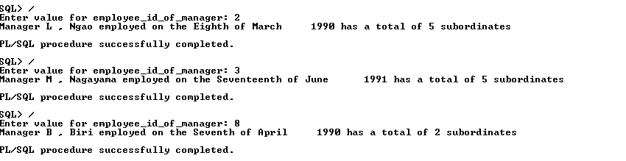

Question 3 (14)

Create a pl/sql block that retrieves employee information. The program must prompt the user to enter employee number and later displays customers that have been assigned to the same employee as their sales representative. Your output must resemble the one below.

declare
v_empid s_emp.id%type;
v_lname s_emp.last_name%type; ½
v_fname s_emp.first_name%type;
v_sd s_emp.start_date%type; ½
v_cname s_customer.name%type;
v_cid s_customer.id%type ½ :=&customerid ✓
begin
select e.id, first_name, last_name, start_date, name,c.id ½
into v_empid, v_fname, v_lname, v_sd, v_cname, v_cid ✓½
from s_emp e, s_customer c ✓✓
where e.id(+) ½ = c.sales_rep_id ✓
and c.id = v_cid; ✓

dbms_output.put_line( 'Employee '||nvl(v_empid,00) ||' '|| ✓
substr ✓ (nvl(v_fname,'Unknown'),1,1) ||' '|| ✓
nvl(v_lname,'Unknown') ||' employed on '|| ✓
nvl ✓ (to_char(v_sd),'Unknown') ||' is a sales rep of '||v_cname||' '||v_cid); ✓
end;
/

